Step 1:

After reading the data into Tableau, I found that the **headers** are in a mess. Many headers are named with F followed by numbers. So I tried to use Tableau’s feature “**Clean with Data Interpreter**”, then the headers are in readable form.

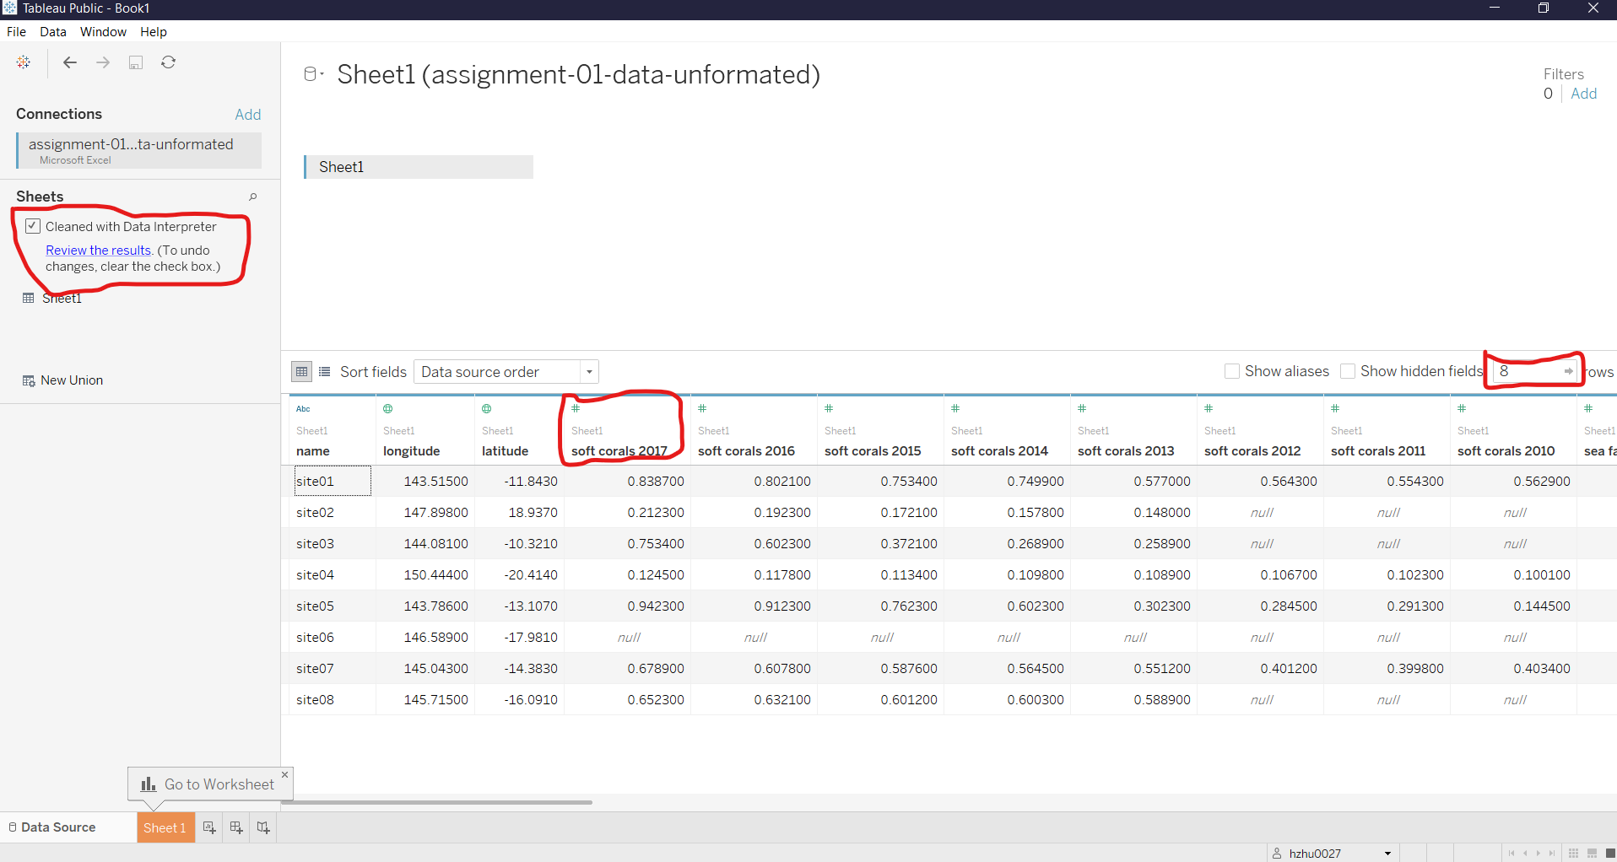

Step 2:

After that I selected all the columns **except** ‘name’, ‘longtitude’, ‘latitude’ and used the feature ‘**Pivot**’ to make the data source in favor of **row-oriented form**. Also I **renamed** some columns to make them more meaningful (‘**corals and year**’, ‘**percentage of bleach**’).

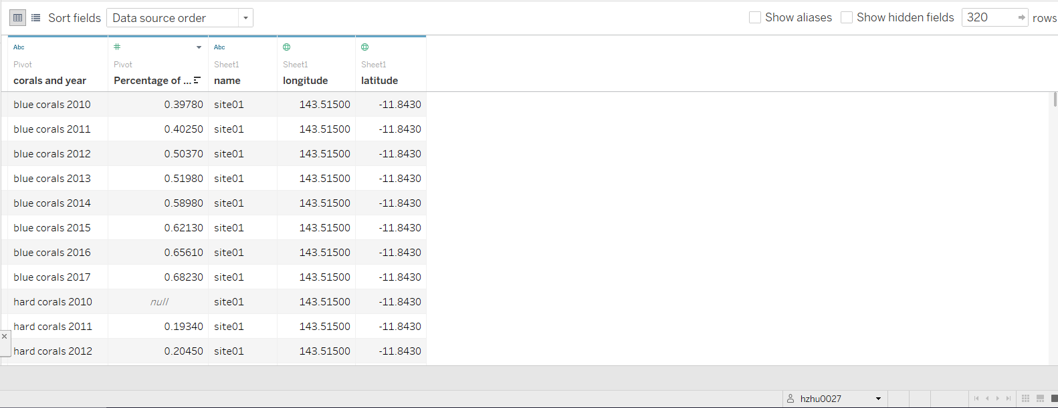

Step 3:

Next I tried to use **bar chart** to explore the data a bit. I found that at **site07, blue corals 2013**’s data doesn’t make sense because it’s so different than the data before and after 2013. In 2012 the percentage of bleach on blue corals at site07 was **0.457** and in 2014 it was **0.473**. Overall from year 2010 to 2017 you only see an **increase trend** but for year 2013 the percentage drop to **0.005**. This is logically unreasonable and probably is a result of **mistyping**. I would go back to the data source and change it manually in a way such that it becomes consistent to the trend or meaningful if it appears to be conflict with the trend. So I go back to the data source and found that for **year 2013 at site07 blue corals**, the error data is probably mistyped and it is supposed to be **0.4696** instead of **0.004696**. So I manually changed it.

Also considering **color blindness**, I eliminates red and green colors because **red-green blindness** is the **most common** type of color blindness.

Error 1:

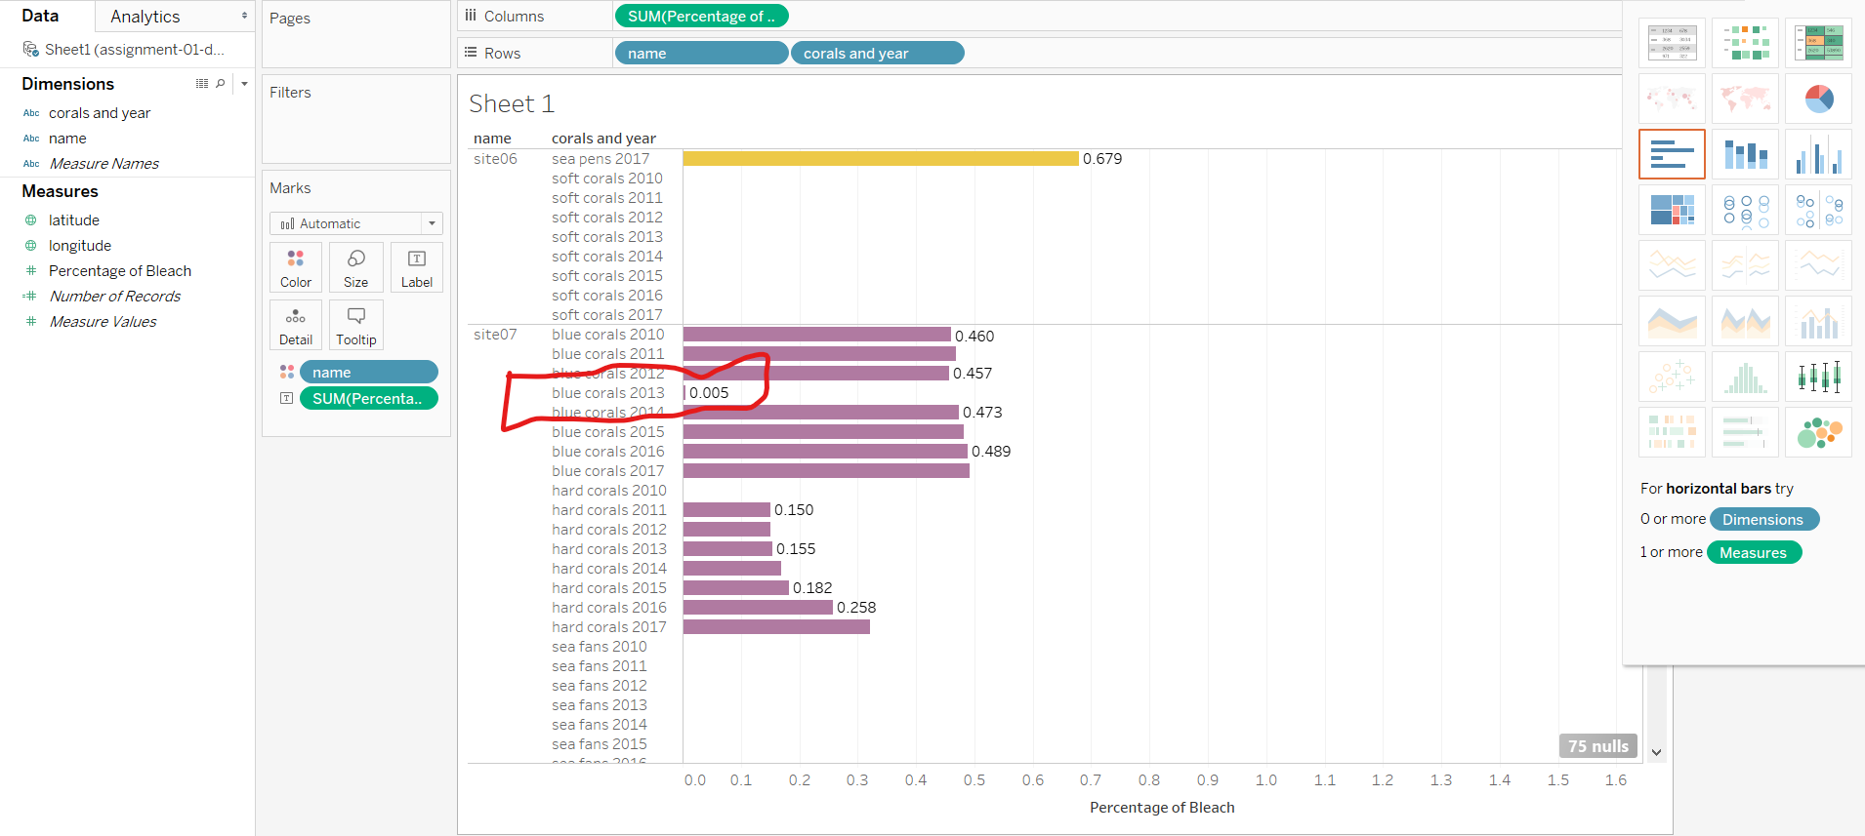

Error 2:

For **site08 on 2014 at hard corals** I found the data once again inconsistent with year before and after. Also that it doesn’t make sense that the percentage of bleach is greater than 100%. So I go back to data source and investigate the value and decided to change it to **14.88%** instead of **148.8%** so that it is consistent with the year before and after 2014.

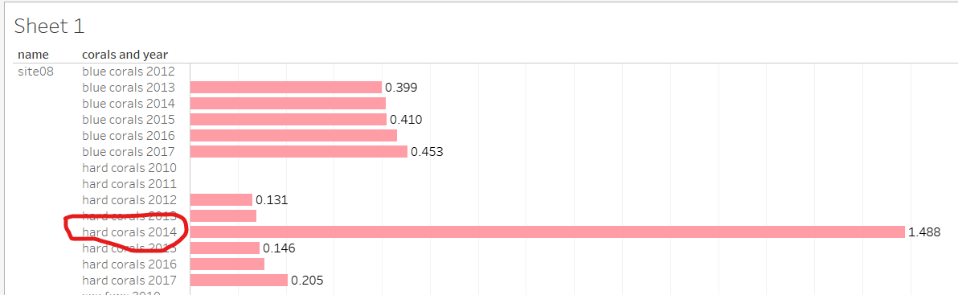

Error 3:

After generating a **map** using the longitudes and latitudes, I found that there’s one error about the **location of site02**. And after investigation, I found the error to be a lack of negative sign on the latitude of site02. It was **18.937** but I changed it to **-18.937** so that it is consistent with all other sites’ latitude because all others have a negative latitude for they are in the south part of The Earth.

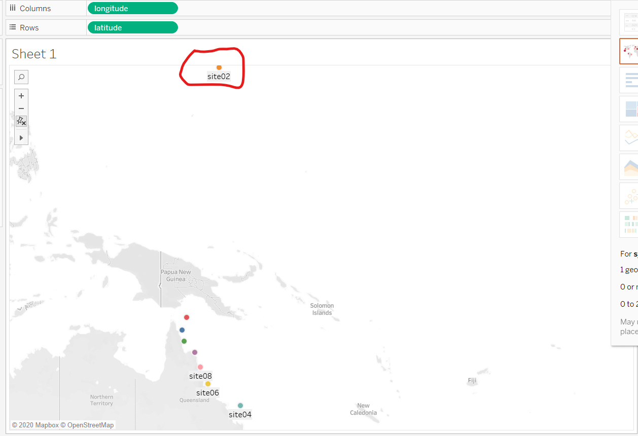

In order to generate a **trend line** for different kinds of corals, I **rearranged** the data source and **split** the column [**Corals and Year**] into **3 sub columns** separated by **‘single space’**. Then I changed the ‘**Year**’ column **data type** from ‘**Number**’ to ‘**Date**’ because ‘Date’ is the proper data type for this column. Also I

**concatenated** the other two columns using a **custom function** “Str([name1])+’ ‘+Str([name2])” and renamed this column to **‘Coral Kinds**’. After that I **hide** the two split fields that are used to perform calculation.

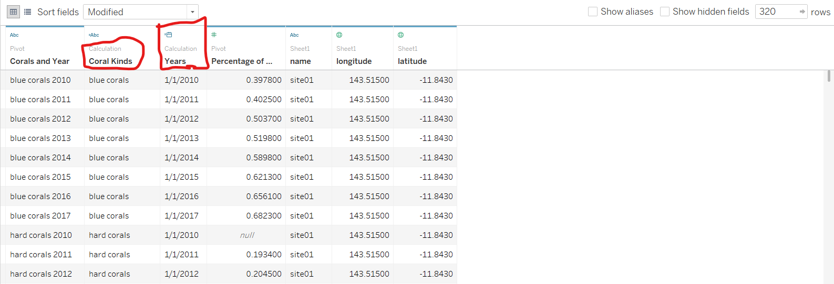

**Q1) In which years and for which kinds of coral is bleaching the worst?**

In order to find out the answer to this question, I believe taking **average** of the % of bleach across 8 sites is necessary. Then I perform ‘**quick table calculation**’ on % of bleach ‘**Difference**’ with regards to **year** for all 5 coral kinds. This way, the peak points indicate the ‘**worst**’ % of bleach and their corresponding years are also indicated. Thus, for ‘**Hard Coral**’, on **2017** is bleaching the worst; for ‘**Sea Fans**’ it was **2016**; for ‘**Sea Pens**’ it was **2017**; for ‘**Soft Coral**’ it was **2014**; for ‘**Blue corals**’ it was **2016**.

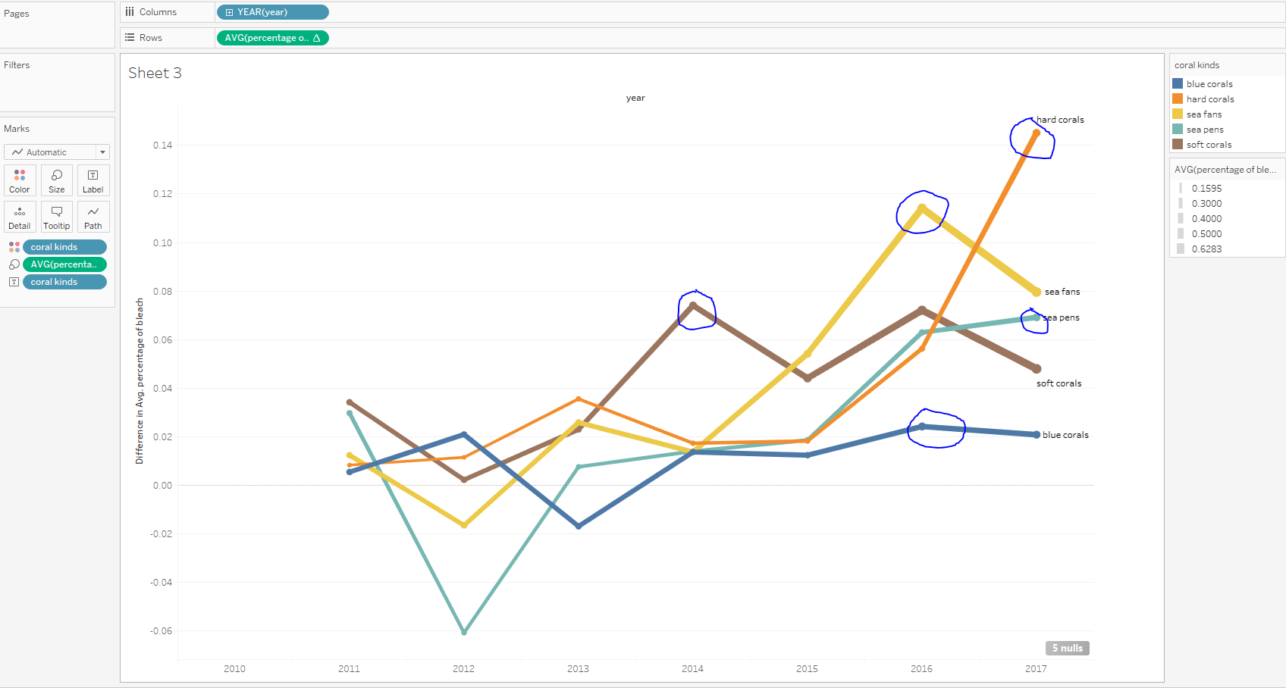

**Q2) How does the location of the site affect bleaching of the different kinds of corals?**

I first plot the 8 sites on the map with ‘**streets**’ option on ‘**Background Maps**’. Then choose name on the color (eliminate red and green colors for color blindness friendly purpose); choose **name** on ‘**label**’, show **maximum** percentage of bleach on ‘**label**’. Also I put ‘**coral kinds**’ on ‘**columns**’ to show 5 facets in the panel.

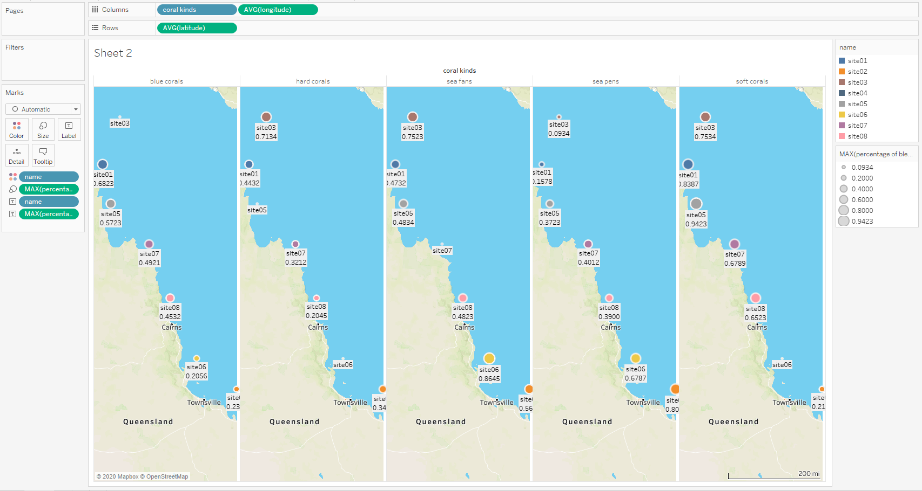

First I compare **‘Blue Coral’**. As shown in the left most graph, it appears that **the closer to the north (higher latitude), the more severe the bleach**. Site 02(the south most site) seems to be an outlier to the rest but it’s also the East most site among all, hence maybe the larger the longitude (the further to the East), the more impact on the bleach. This could potentially indicate that the temperature plays an impact on the bleach.

For **‘Hard Coral’**, it follows the same pattern as ‘Blue Coral’**, the higher latitude, the more impact on the bleach** and site 02 reveals that the larger the longitude, the more impact on the bleach.

For **‘Sea Fans’**, there **isn’t** an obvious pattern on how latitude and longitude affect the bleach.

For **‘Sea Pens’**, it appears that **the lower the latitude, the more impact on the bleach** because the bleach percentage are higher as the location moves to the south.

For **‘Soft Corals’**, it seems overall, **the higher the latitude the more impact on the bleach** except site 03 and site 01. The reasons why they are not bleaching as worse as site 05 can’t be revealed by this comparison. But again, overall, the higher the latitude, the more impact on the bleach is the pattern.